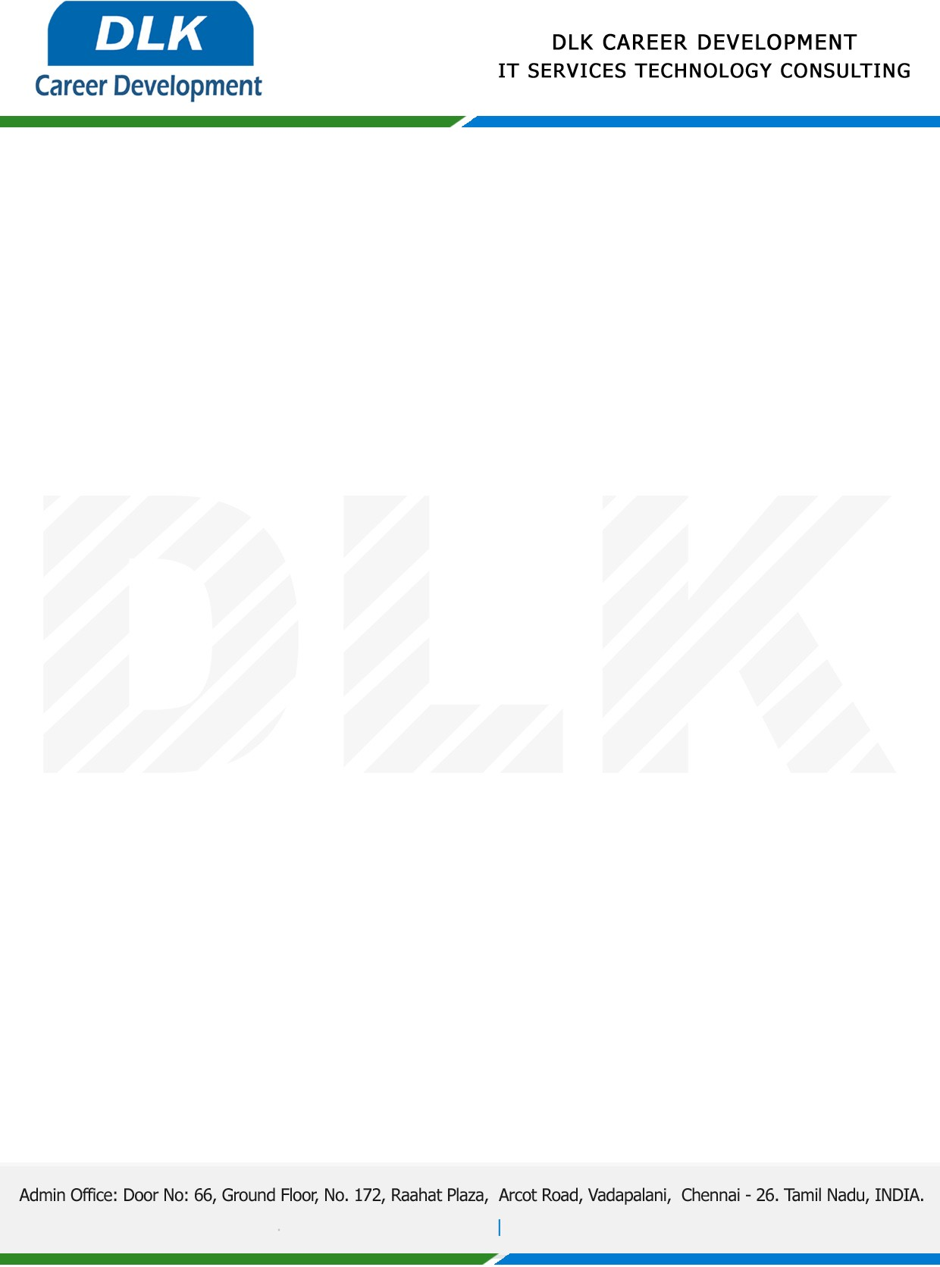

Date: 28 /December/ 2022

**To**

Department of Computer Science

Head of Department,

Shri Shankarlal Sundarbai Shasun Jain College for Women.

**Sub: Letter of Project Acceptance**

This is to certify that **MS MALARVIZHI P (REG NO:** **832100568)** final year student of has accepted the Project Work duration from **1st December 2022 to 29th April 2023** under the domain **“Python”.** During the Project, all information and data collected from you should be kept confidential.

**Topic**: Emotion detection and recognition using deep learning

We appreciate your interest in **DLK CAREER DEVELOPMENT**

